Instructional Science Unit

Nuclear Power Plants
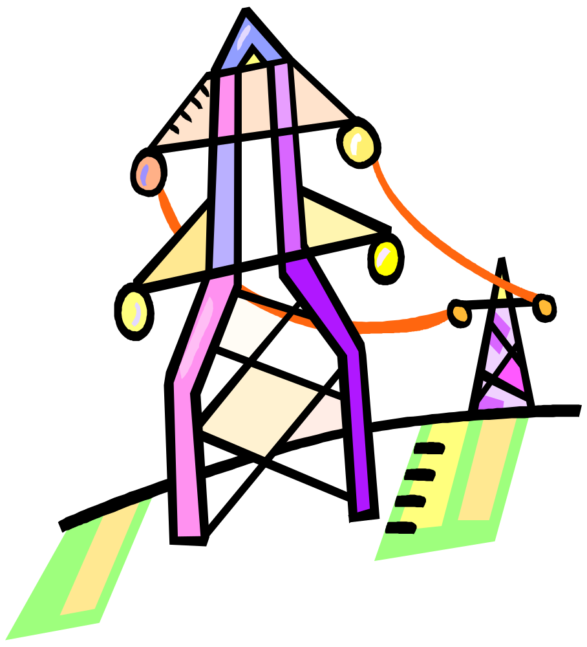

Lynne M. Bailey
MST II NYIT Fall, 2007
Prof. Stan Silverman
Indian Point Nuclear Power Plant,
Buchanan, New York
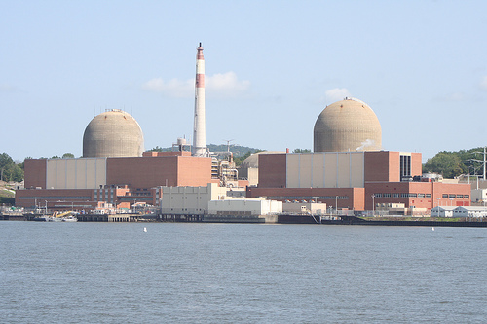
http://www.flickr.com/photos/neatnessdotcom/245778426/

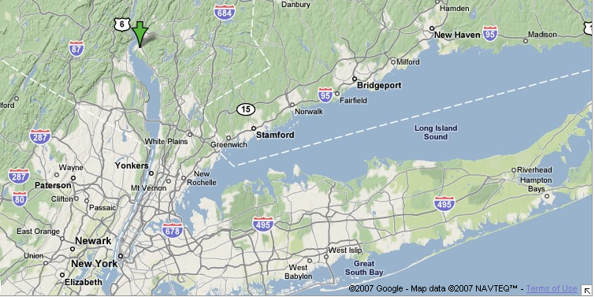

Table of Contents
Project Description 5
Intended Audience (grade, learning level) 5
How long will the instructional activities take the student 5
Description of Pre-Activities leading up to the project 5
Description of Post-Activities 6
How would you differentiate the instruction to meet the varied learning levels of the students? 6
Describe how your lessons maximizes the learning in math, science and technology 7
What modifications would be required to your lesson… 8
Essential Questions 10
Should the Indian Point Nuclear Facility in Buchanan NY be closed? 10
Objectives 10
Activities 11
Day One – How radioactive are you? 11
Day Two: Nuclear Power Plants 13
Day Three: Strategies for Decision Making 14
Day Four: Visit Indian Point Energy Center 15
Days Five -- Seven: Research Information 15
Days Eight and Nine – Create Group Presentation 16
Day Ten – Extra Time Allotment 16
Days Eleven – Twelve Present Project 16
Day Thirteen – Summarize 16
Assessment Rubrics 16
General Class Rubric 17
Project Rubric 18
Essay Rubric 19
Performance Indicators 19
Standard 4: Science 19
Standard 5: Technology 19
Standard 7: Interdisciplinary Problem Solving 21
Rationale 21
Bibliography Including Web Resources 23
Related Lesson Plans 23
Extension Activities / Curriculum Integration 24
Project Descriptions 25
Curriculum Pages 25
Nuclear Power and Power Plants 26
Uranium and Nuclear Energy 27
Discovery of Uranium and Radioactivity: 29
Atomic Physics 29
Indian Point Nuclear Power Plant Facility 29
Nuclear Power Plant Accidents 30
Hands-on Experiments/Demonstrations 31
Fossil Fuels 31
General Energy Information 31
Appendix 33
Personal Radiation Worksheet 33
Cloud Chamber Experiment 34

Unit Title: Nuclear Power Plants

Project Description
In this unit, student learning will focus on nuclear power plants. According to FEMA, nearly three million Americans live within 10 miles of a nuclear power plant. The Indian Point Nuclear Power Plant is one such facility located within a 50-mile radius of New York City. New York’s Attorney General, Andrew Cuomo recently announced that he and the Governor New York oppose renewing the license for Indian Point to continue operations and want the plant decommissioned as soon as possible. In this unit students are asked to form their own opinion about Indian Point.
After reviewing radioactivity and the press announcements, students will formulate a set of questions that they need to answer in order to make an informed decision. Using a jigsaw learning strategy, they will be assigned to cooperative learning teams and break out into expert groups to conduct a more detailed study in search of answers to those questions. Each student will create some artifact to evidence the learning of their expert group. Upon returning to their primary units, students will then share their knowledge with the others, build a consensus on the issue, create a presentation to convey their opinion and present it to the entire class.
This unit also includes a field trip to visit and tour the nuclear power plant at the Indian Point Energy Center.

Intended Audience (grade, learning level)
High school students, grades 10 - 12 Chemistry Class. This unit can be easily adapted for use with grades 7-12 and/or for other disciplines by adjusting levels of depth and detail.

How long will the instructional activities take the student
Twelve- Fourteen (12-14) 45 minute class periods are planned for. Unit includes a field trip which will take the better part of a day.

Description of Pre-Activities leading up to the project
Students previously learned about power plants and how electricity is generated and distributed, and they are aware of the energy crisis (rising demand, limited resources and price escalation), climate changes and negative environmental effects and dangers created by some of these plants. Recently, they studied atomic fission and radioisotopes and will now look at how this science is used in creating electricity, and the techniques and issues surrounding this controversial source of energy. A movie segment or video about the effects of radioactivity should be seen by students shortly before starting the unit showing positive uses (medicine) and negative effects of radioactivity. Videos can be found at PowerMediaPlus.com (subscription required, free to all NYC teachers), such as Classroom Media’s Radioisotopes at Work, and on YouTube, such as Victims of Radiation at http://www.youtube.com/watch?v=w6nkLANrVlM.
Teacher should arrange for visit to Indian Point (or other power plant facility) about a month beforehand. To schedule a tour of Indian Point, call Kathy McMullen at 914.271.7132. For security reasons, Con Edison does not offer tours of any of its facilities. It may be feasible for students on Long Island to tour the nuclear plant in Waterbury, CT via ferry from Port Jefferson. Administrative requirements for student field trips need to be fulfilled as well.

Description of Post-Activities
Invite an activist to discuss nuclear energy issues and how students can get involved in promoting their agenda. Students will write letters expressing their opinions to appropriate government officials and look for opportunities to support efforts for their cause.

How would you differentiate the instruction to meet the varied learning levels of the students?
Presented materials will be grade appropriate and alternate materials will also be available at various reading levels. Multiple media formats will be available as well to accommodate different learning styles. Computers will be equipped with text-to-speech, speech-to-text and translation applications for students with needs in those areas.
Carefully constructed learning teams based on student strengths, weaknesses, and academic performance, are an integral part of this unit and a tool to differentiate instruction. Groups should also be as heterogeneous as possible. Student members will have complimentary skill sets and be able to assist each other and perform different roles. An ESL student would be in a group that has another member who speaks both languages fluently. Students will be expected and encouraged to assist each other and draw on each member’s strengths and intelligences, using peer teaching, studying, evaluation and joint activities. Student constructions will not be limited to one type of artifact, nor will their research be limited to one kind of media which gives students flexibility. Technology facilitates differentiating instruction, as to pace, learning styles and presentation. Students with IEP’s will be afforded appropriate modifications and in collaboration with their resource teacher, supplemental activities or other materials provided to optimize learning.

Describe how your lessons maximizes the learning in math, science and technology
Science Lens: The study of nuclear power plants involves science learning at many different levels. There are strands from chemistry, biology, physics, and earth science present. This lesson proceeds on the basis that students are already familiar with how energy is converted to different forms and how electricity is created. Atomic energy involves learning more about the structure of the atom, the chemistry and physics of fission, creation of radioisotopes and radioactive decay. Where does radiation come from? What happens when a living organism interacts with radioactive materials? How does radioactive material affect an ecosystem? How can radioactivity be contained? How is nuclear fission used in an electrical power plant? What is a chain reaction and how is it controlled? Where in the electromagnetic spectrum is radiation? How is uranium enriched? How can spent fuel be reprocessed? Experimental activities are offered to give students some physical activity to demonstrate a number of these principals. Students will have to make observations and connect those to the subject matter.
In order to answer the EQ, student must strategize logically, gather information, make observations and support a position akin to supporting a hypothesis. To make an informed decision they will have to investigate, analyze and evaluate data about how nuclear power plants work and research their hazards and drawbacks.
Math Lens: Students may be recording and graphing scientific observations. They will calculate a Personal Annual Radiation score, compare it and average the results among classmates. They will evaluate safety records and make judgments about the probability and possibility of nuclear power plant accidents and compare it to alternatives. They will calculate half-lives of radioactive material, use scientific notation, and count atomic particles. They could chart percentages of power production and usage, by region and type. They could estimate and chart future trends or evaluate related data. Students will analyze and compare economic data. They will analyze and compare data about greenhouse gasses, and millirems, and may compare the impact of alternative fuels. Students will analyze and evaluate the costs and benefits of continued operations versus ceasing operations.
Technology Lens: How is the design and construction of nuclear plants different from other plants? What materials are used? How are they assembled? What processes are required to decommission a nuclear power plant? How can radioactive waste be safely stored, transported, contained and/or cleaned up? How is uranium mined, enriched and refined? How do you use a Geiger Counter? Students may construct artifacts requiring choosing and assembling materials to create models or other representations of information.
Students may use also digital technologies to create and present information, including audio/visual equipment, digital cameras, and computer applications to create essays, letters, presentations, videos, databases, time lines, literary scenes, podcasts, newsletters, petitions and questionnaires. Students will use information technologies to organize, search for and research the subject matter, and to write letters, record journal entries, post blog entries, use wikis as needed and if available.

What modifications would be required to your lesson…
… in a single computer environment, classroom cluster environment or lab environment: Frankly, it would be a hindrance to conduct this unit in a single computer environment because of the research involved. In such an environment I would use the computer with LCD projector and/or Smartboard for presenting multi-media materials, web pages and use it during whole-class activities. I would print out much more material from the Internet, create DVD’s of any videos for playing on other equipment, and perhaps CD’s as well for students to use at other locations. It is very likely that I would find some alternate ways to provide at least one computer for each group. Some of the material could be recorded and played using alternative devices. I could bring in my personal laptops (2), and know that I could borrow at least one more. Even in schools that have only 1 computer in the classroom, there is often a laptop cart available, a school library or lab that teachers can arrange to use with their students. As students will be required to conduct research, it is also possible to obtain additional print and video materials from libraries, government and public organizations, and corporations. With only one computer, groups would have to assign a team member to use the computer and computer time allocated and scheduled for each group. Final projects and individual artifact assignments may have to be altered to use less computer technology and alternative resources.
A computer lab can also present problems with a unit like this. Many labs do not have workspaces available for students to conduct other experiments and may make it difficult for teamwork. In my lab, I arranged 25 computers around the perimeter of the room and had worktables in the center. This was an ideal arrangement for group work. In a lab setting, each student is assigned a computer in proximity to group members. With a jigsaw strategy, more flexibility is required to regroup students as the unit progresses. It may be necessary to arrange for a different classroom to accommodate student research and exploration of the subject matter for part of the unit. It would be great for each team member to have equal access to a computer; teams still need to manage their activities to optimize computer use and sharing of information.
In a classroom cluster environment, each group should have access to at least one computer. Teams must once again develop a strategy to optimize computer usage to complete their tasks.
Under any of these scenarios, I would still have printed reference materials available that covered the basic information for the subject matter.

Science Unit: Nuclear Power Plants

Essential Questions

Should the Indian Point Nuclear Facility in Buchanan NY be closed?

New York State Governor Mark Spitzer and Attorney General Andrew Cuomo announced that they support closing the nuclear power plant facilities at Indian Point. New York City’s Council is interested in the issue and has asked you to advise them.
Your group will research, prepare and present your findings to the Council.
Would you close the facility, or, are you in favor of renewing the operating license and why? Your presentation will state your recommendation and elaborate on your findings and reasoning.
Andrew Cuomo’s announcement: http://www.nytimes.com/2007/12/04/nyregion/04nuke.html
Entergy response: 12/3/2007 http://www.entergy-nuclear.com/news_room/newsrelease.aspx?NR_ID=1083

Objectives
Students will be able to
- Describe the sources and dangers of radioactivity.
- Discern, describe and evaluate essential issues regarding nuclear energy, i.e., safety, waste disposal, security, safeguards, transportation, procurement, decommissioning and construction integrity.
  - Identify, analyze and evaluate different electric generating systems.
  - Understand how different power plants are quantified and be able to interpret data that they are presented with.
- Formulate a considered and informed opinion and plan of action to help address regional energy issues.
- Present research and conclusions in a professional and meaningful manner.

Activities

Day One – How radioactive are you?

Aim: How does radioactivity affect us?
Imagine you woke up this morning to the news that there was an accident at a nuclear power plant 40-50 miles away from your home. What would you do? Are you in danger? How would prepare for a nuclear accident? What if you lived only 5 miles from the plant?
DO NOW: TPS initial responses. Enter in journal/ blog. Share out with class.
Activity: In groups, students research emergency preparedness on the Internet (FEMA website at http://www.fema.gov/hazard/nuclear/index.shtm) and respond to the questions using a Wiki, blog or group journal.
Ask: What makes nuclear power plants especially dangerous? [Radioactivity] Ask: How is that harmful/how does radioactivity hurt us? Allow short time for additional research on harmful effects of radiation and share responses.
Activity: Ask: In your research, and from previous classes, what do you know about radiation? Where does it come from? Students should be able to describe fission and identify radioactivity with unstable atoms. What properties does it have? [Invisible, all around you, can be harmful in large doses, may not harm you]. Do you know how it is measured? (Millirems)
Ask: What’s your average annual dose of radiation?
Activity: Students complete individual worksheet (available online at http://www.nrc.gov/reading-rm/basic-ref/teachers/average-dose-worksheet.pdf) and calculate their average annual dose. Tally results in groups and compare. Ask what they their observations and hypothesis are. Do any of them have radiation sickness? Are small doses of radiation generally harmless? Continue discussion of effects drawing upon previous studies. What else do you notice about radiation? Confirm that it is invisible. How would know if radioactive levels were high/harmful? [Geiger counter, effect on other organisms] What else do you know of that you can’t see but can hurt you? Hint: Many homes have detection devices A: Carbon dioxide; also, homes are tested for Radon, naturally occurring radiation.
Whole class lecture: Inform/review radioactivity. Demonstrate Geiger Counter if possible/available. Activity outline online at http://www.nrc.gov/reading-rm/basic-ref/teachers/unit1.html#activity_2 . Compare a Geiger Counter to a metal detector.
Supplemental Resource: US Department of Energy, The Harnessed Atom, Unit 2, pp. 17-52, Understanding Atoms and Radiation
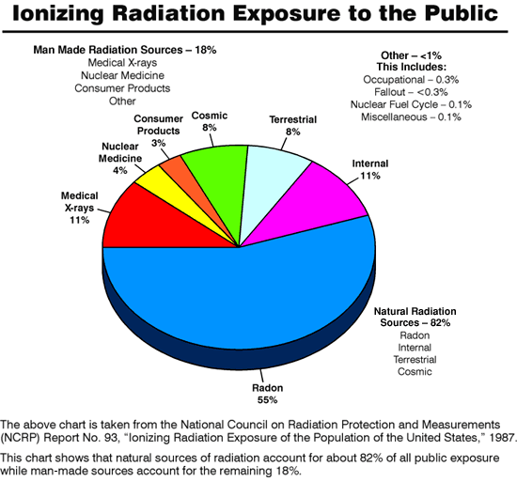
http://www.nrc.gov/reading-rm/basic-ref/teachers/unit1.html#lesson Large amounts of radiation -- far above the levels encountered in daily life -- can produce cancer and genetic defects in living organisms. Radiation causes damage and alters the body's normal cells and normal cell function. This breakdown in normal cell function may result in an uncontrolled growth of cells, hence the potential for malignant/cancerous tumors.
Whether the source of radiation is natural or man-made, whether it is a small dose of radiation or a large dose, there will be some biological effects. A diagram can show the biological effect of ionizing radiation.
Radiation causes ionizations of atoms that will affect molecules that may affect cells that may affect tissues that may affect organs that may affect the whole body.
[Write the following on the board]
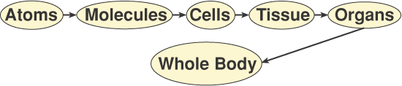
Although we tend to think of biological effects in terms of the effect of radiation on living cells, in actuality, ionizing radiation, by definition, interacts only with atoms by a process called ionization. Thus, all biological damage effects begin when radiation interacts with atoms forming the cells in the human body. As a result, radiation effects on humans proceed from the lowest to the highest level as noted on the board.
[Radiation causes ionizations of atoms that will affect molecules that may affect cells that may affect tissues that may affect organs that may affect the whole body.]

Day Two: Nuclear Power Plants

Aim: How does nuclear energy create electricity?
Do Now: TPS Ask students to brainstorm word-associations and connections about radiation, nuclear energy, and nuclear power (words on board). Allow students a few minutes to jot down words and phrases, create brainstorm chart in groups. Process guide for brainstorming can be found here: http://projects.edtech.sandi.net/staffdev/tpss99/processguides/brainstorming.html
Next: Whole class discussion: Discuss answers and build chart on board. Have students construct KWL chart on nuclear power plants in groups.
Inform: Display NRC website page on nuclear plants with animated illustration. Ask: How does nuclear energy power the generator, and how does this compare to other energy sources (fossil fuels, biomass and geothermal are used to create steam; hydroelectric, solar and wind convert kinetic energy directly to mechanical energy)? Where do you see the danger of radioactivity? How does the design mitigate leakage of radioactive materials? Students study schematic to ask and answer questions regarding design of plant. Display photos of power plants.
Activity: Create quick sketch, diagram or other representation of nuclear power plant design.
Transition: Photo of Indian Point.
Consider the EQ and Scenario of the unit: Should Indian Point be closed? Display statements of Andrew Cuomo and response from Entergy.

Day Three: Strategies for Decision Making

Aim: How do we make an informed Decision?
Do Now: Display and hand out articles relevant to EQ. In groups, students brainstorm list of items they will need to know to make an informed decision about Indian Point.
Whole Class: Share results and create matrix for project completion. Students should devise a strategy and list of required elements. Projects can take several forms. Guide students’ selection. Build on points you want students to explore in subsequent days.
Inform: Let students know they will have a total of 3 class periods to research and create presentations. Presentations will be made in class on the following day. Students will receive a group grade, complete an individual artifact for the group presentation, evaluate other group’s work and write a separate opinion paper for an individual grade as an at-home assignment.
Strategy for Project: Students will work in cooperative learning groups of 4-5 students. Per class discussion, they have decided to research more fully several aspects of the situation, i.e., the design and function of nuclear power plants, how they work and safeguards; safety and security, including waste disposal issues, accidents and potential dangers, and the impacts of decommissioning Indian Point from both economic and environmental perspectives. Expert groups will assemble (jigsaw) to investigate each segment. The required elements of their projects will include an 8-10 minute presentation of their position with specific facts about Indian Point, including an artifact from each expert group, a summary of their findings and conclusions. Several reasons will be specified for closing or continuing operations at Indian Point. Students can create a PowerPoint presentation, use paper charts, graphs, photographs, newspaper clippings, models, role-play scenarios or other format to present their findings.
Activity: Students prepare for visit to Indian Point by reviewing trip logistics, power plant schematics, listing questions and will share out with class. A process guide for interviewing, which provides good tips for asking questions, can be found online at http://projects.edtech.sandi.net/staffdev/tpss99/processguides/interviewing.html.
Activity: Use remaining time for students to begin research in expert groups. Students will be given a list of resources (see curriculum pages) to begin their research.

Day Four: Visit Indian Point Energy Center

Aim: How does the Indian Point Energy Center create power for the region?
Visit Power Plant. Students ask appropriate questions from lists they have prepared and as tour allows.

Days Five -- Seven: Research Information

Aims: How do you use the Internet to research and collect data for your project? How do you use technology to construct projects?
Expert groups will continue to research the previously discussed topics. Students use list of resources (see curriculum pages) and supplement them as needed with other resources. Students might like to write to a scientist or request a speaker/ videoconference with a scientist at Brookhaven National Lab http://www.bnl.gov/est/neis/ and view additional videos as part of their research. Each student in an expert group will need to familiarize themselves with material and share that knowledge with their primary group.
Individually, students create an artifact which can be used in their primary group’s presentation. Artifacts may include models, records and graphs of experiments (see Appendix), collages, poems, video, illustrations, photographs and other such representations of their work in an expert group. Students are working in groups and are encouraged to pool information, share ideas and data, but must create an individual artifact for this project. For example, as a group they may execute an experiment together, take photographs and videos, but then each person will need to create their own record, graph, chart or similar and summary. Teacher and other group members facilitate work by assisting students with questions, problems, demonstrating tools and guiding work on artifacts as needed.
A process guide for time management is online at http://projects.edtech.sandi.net/staffdev/tpss99/processguides/time_manage.html.

Days Eight and Nine – Create Group Presentation
Students meet in cooperative groups to build consensus and put presentation together to support opinion. Process guide for building consensus can be found online at http://projects.edtech.sandi.net/staffdev/tpss99/processguides/consensus.html.

Day Ten – Extra Time Allotment
Students have time for refining artifacts and group presentation.

Days Eleven – Twelve Present Project

Aim: How do you Present Findings
Students present projects and assess other group’s project per rubric.
Individual at Home Assignment due next day: Write persuasive essay detailing your own opinion and reasons. (Assignment announced several days previously.) A process guide for writing such an essay is online at http://projects.edtech.sandi.net/staffdev/tpss99/processguides/persuasive.html.

Day Thirteen – Summarize
Teacher facilitates class discussion of unit with students to assess learning experience. If possible, arrange for teleconference or videoconference call with scientist in the field or representative activist(s).
Activity: Students express opinions and reasons in other media, by letter writing, signing petitions, posting and/or commenting in blogs, etc.

Assessment Rubrics
Individual assessments based on artifact created, and rubrics. Open-book project or oral presentation may be substituted for essay for IEP /ESL students. Group grade also assigned based on teacher and classmates’ feedback.

General Class Rubric
Component | 1  Never | 2  Rarely | 3  Sometimes | 4  Usually | 5  Always

On time & Prepared
Student arrived on time for class (1 minute grace period) or had late pass, had notebook, writing instrument and promptly seated him or herself

Do Now
Student began do now promptly and diligently completed task

Class Participation & Demeanor
Student courteously participated in class discussions, collaborated with group partner and constructively assisted others; Student behaved with respect for persons and property

Major Class Activity
Student completed all aspects of major class activity diligently and assisted others if finished early or added something extra to the assignment
Totals

Project Rubric
Category | 4 Excellent | 3 Very Good | 2 Good | 1 Needs Improvement | Score
Graphics - Relevance | All graphics are related to the topic and make it easier to understand. All borrowed graphics have a source citation. | All graphics are related to the topic and most make it easier to understand. All borrowed graphics have a source citation. | All graphics relate to the topic. Most borrowed graphics have a source citation. | Graphics do not relate to the topic OR several borrowed graphics do not have a source citation.
Required Elements | The project includes all required elements as well as additional information. | All required elements are included in the project. | All but 1 of the required elements is included on the poster. | Several required elements were missing.
Attractiveness | The project is exceptionally attractive in terms of design, layout, and neatness. | The project is attractive in terms of design, layout and neatness. | The project is acceptably attractive though it may be a bit messy. | The project is distractingly messy or very poorly designed. It is not attractive.
Grammar | There are no grammatical mistakes on the poster. | There is 1 grammatical mistake on the poster. | There are 2 grammatical mistakes on the poster. | There are more than 2 grammatical mistakes on the poster.
Knowledge Gained | Student can accurately answer all questions related to facts in the poster and processes used to create the poster. | Student can accurately answer most questions related to facts in the poster and processes used to create the poster. | Student can accurately answer about 75% of questions related to facts in the poster and processes used to create the poster. | Student appears to have insufficient knowledge about the facts or processes used in the poster.
Use of Class Time | Used time well during each class period. Focused on getting the project done. Never distracted others. | Used time well during each class period. Usually focused on getting the project done and never distracted others. | Used some of the time well during each class period. There was some focus on getting the project done but occasionally distracted others. | Did not use class time to focus on the project OR often distracted others.
Content/ Focus | Topic/subject is clear, though it may/may not be explicitly stated. | Topic/subject is generally clear though it may not be explicitly stated. | Topic/subject may be vague. | Topic/subject is unclear or confusing.
Comments/ Total Score

Essay Rubric
Category | 4 Excellent | 3 Very Good | 2 Good | 1 Needs Improvement | Score
Required Elements 50% (Double Score) | Many essential elements included as well as additional information. Fully engages reader and explains subject's significance. | Sufficient essential elements included to engage the reader and explain who this person is and why they are important. | Included a few essential elements. Explains somewhat who this person is and their importance | Most required elements were missing. Doesn’t really explain why this person is important.
Spelling and Punctuation 25% | There are no spelling or punctuation errors in the final draft. Character and place names that the author invented are spelled consistently throughout. | There is one spelling or punctuation error in the final draft. | There are 2-3 spelling and punctuation errors in the final draft. | The final draft has more than 3 spelling and punctuation errors.
Organization 25% | The essay is very well organized. One idea or scene follows another in a logical sequence with clear transitions. | The essay is pretty well organized. One idea or scene may seem out of place. Clear transitions are used. | The essay is a little hard to follow. The transitions are sometimes not clear. | Ideas and scenes seem to be randomly arranged.

Comments
*Essential Elements: Clearly stated issue and opinion, listed 7 accurate facts, described 3 reasons to support opinion

Performance Indicators

Standard 4: Science
Students will understand and apply scientific concepts, principles, and theories pertaining to the physical setting and living environment and recognize the historical development of ideas in science.
Physics: NYS MST2: Science - Physical World.
Key Idea: Energy exists in many forms, and when these forms change energy is conserved.
Performance Indicators:
- observe and describe heating and cooling events
- observe and describe energy changes as related to chemical reactions
- observe and describe transmission of various forms of energy
- explain the uses and hazards of radioactivity

Standard 5: Technology
Students will apply technological knowledge and skills to design, construct, use, and evaluate products and systems to satisfy human and environmental needs.
Engineering Design
Key Idea: Engineering design is an iterative process involving modeling and optimization used to develop technological solutions to problems within given constraints.
Performance Indicators
• initiate and carry out a thorough investigation of an unfamiliar situation and identify needs and opportunities for technological invention or innovation
• identify, locate, and use a wide range of information resources including subject experts, library references, magazines, videotapes, films, electronic data bases and online services, and discuss and document through notes and sketches how findings relate to the problem
• generate creative solution ideas, break ideas into the significant functional elements, and explore possible refinements; predict possible outcomes using mathematical and functional modeling techniques; choose the optimal solution to the problem, clearly documenting ideas against design criteria and constraints; and explain how human values, economics, ergonomics, and environmental considerations have influenced the solution
Technology Systems
Key Idea: Technological systems are designed to achieve specific results and produce outputs, such as products, structures, services, energy, or other systems.
Performance Indicators
• explain why making tradeoffs among characteristics, such as safety, function, cost, ease of operation, quality of post-purchase support, and environmental impact, is necessary when selecting systems for specific purposes
• explain how complex technological systems involve the confluence of numerous other systems
Impacts of Technology
Key Idea: Technology can have positive and negative impacts on individuals, society, and the environment and humans have the capability and responsibility to constrain or promote technological development.
Performance Indicators
• explain that although technological effects are complex and difficult to predict accurately, humans can control the development and implementation of technology.
• explain how national security is dependent upon both military and nonmilitary applications of technology
Optimization
Key Idea: In order to arrive at the best solution that meets criteria within constraints, it is often necessary to make trade-offs.

Performance Indicators
• analyze subjective decision making problems to explain the trade-offs that can be made to arrive at the best solution

Standard 7: Interdisciplinary Problem Solving
Students will apply the knowledge and thinking skills of mathematics, science, and technology to address real-life problems and make informed decisions.
Connections
Key Idea: The knowledge and skills of mathematics, science, and technology are used together to make informed decisions and solve problems, especially those relating to issues of science/technology/society, consumer decision making, design, and inquiry into phenomena.
Performance Indicators
• analyze science/technology/society problems and issues on a community, national, or global scale and plan and carry out a remedial course of action
Strategies
Key Idea: Solving interdisciplinary problems involves a variety of skills and strategies, including effective work habits; gathering and processing information; generating and analyzing ideas; realizing ideas; making connections among the common themes of mathematics, science, and technology; and presenting results.
Performance Indicators All Levels: Students participate in an extended, culminating mathematics, science, and technology project. The project would require students to:
Skills and Strategies for Interdisciplinary Problem Solving
- Working Effectively: Contributing to the work of a brainstorming group, laboratory partnership, cooperative learning group, or project team; planning procedures; identify and managing responsibilities of team members; and staying on task, whether working alone or as part of a group.
- Gathering and Processing Information: Accessing information from printed media, electronic data bases, and community resources and using the information to develop a definition of the problem and to research possible solutions.
- Generating and Analyzing Ideas: Developing ideas for proposed solutions, investigating ideas, collecting data, and showing relationships and patterns in the data.
- Common Themes: Observing examples of common unifying themes, applying them to the problem, and using them to better understand the dimensions of the problem.
- Realizing Ideas: Constructing components or models, arriving at a solution, and evaluating the result.
- Presenting Results: Using a variety of media to present the solution and to communicate the results.

Rationale
We are facing a global energy crisis and global warming. Black-outs and 'brown-outs' are happening more often and we are advised to turn down the heat, or we can't run an air conditioner sometimes. Nuclear energy is in the headlines again with many proposing new plants as they are cost efficient and environmentally friendly, producing little to no greenhouse gasses. There are however, many concerns about the safety and security of constructing additional nuclear power plants.
In New York state 30% of our electricity is generated by nuclear power plants. 40% of that energy comes directly from the Indian point plants, less than 50 miles from New York City. In fact, 20 million people live within a 50-mile radius of the facility. Governor Spitzer and Attorney General Cuomo recently announced that they are in favor of closing the Indian point power plants. The brief detailing their intervention in the licensing procedure is online at http://rds.yahoo.com/_ylt=A0geu9m_RmZHnmAArvNXNyoA;_ylu=X3oDMTFiM2Q5a2pvBHNlYwNzcgRwb3MDMTAEY29sbwNhYzIEdnRpZANQUjAxNl8xMzEEbANXUzE-/SIG=127adals0/EXP=1197971519/**http%3a//www.oag.state.ny.us/press/2007/dec/brief.pdf.
Is this a good idea? This unit looks at the dangers of radioactivity and the advantages of nuclear power plants and asks students to form a well considered opinion on this issue.
The arguments against nuclear power plants are primarily those of safety and security. The industry claims a sterling track record especially when compared to other power sources. In France, about 75% of the nation’s electricity is produced by nuclear plants, and there have been no serious incidents. Many questions remain however, and students should consider the probability and possibility of an accident at a facility so close to home.
Safety issues: procurement, transportation, plant safety, waste management, decommissioning of plants; Security regarding potential adverse use of radioactive materials by terrorists or to expand weapon programs and general security of the plants. How abundant are supplies? Is it really safe to store spent reactor fuel deep inside a mountain? Will geological changes and water supply impact current and future sites and how? What part of a comprehensive energy plan for the region or nation should nuclear energy have? How cost-effective is nuclear energy? How do nuclear plants compare with other kinds of power plants? If Indian Point is closed, what would be the economic impact? How would the capacity be replaced and at what cost (monetarily and environmentally)?
Deaths and accidents from nuclear power plants have occurred. What were the effects of these (3 Mile Island, Chernobyl and other incidents)? What about other incidents? How does extracting and refining uranium compare with fossil fuels?
What are the arguments in favor? Good supply, almost no pollution, relatively inexpensive, known technology, ongoing research to minimize safety concerns and improve designs and safeguards.

Bibliography Including Web Resources
Applebome, Peter, The power grid game: Choose a Catastrophe, New York Times, December 9, 2007
CASEnergy Coalition CASEnergy Classroom website online 12/10/07 at http://www.cleansafeenergy.org/CASEnergyClassroom/HowaNuclearPowerPlantWorks/tabid/170/Default.aspx
Cohen, Bernard, The Nuclear Energy Option, Plenun Press, 1990, book online 12/10/07 at http://www.phyast.pitt.edu/~blc/book/index.html
Committee on Alternatives to Indian Point for Meeting Energy Needs, National Research Council, Alternatives to the Indian Point Energy Center for Meeting New York Electric Power Needs, The National Academies Press, Washington, D.C., 2006 online 12/16/07 at http://www.nap.edu/catalog.php?record_id=11666#toc

Energy Information Administration, An Introduction to Nuclear Power, website online 12/10/07 at http://www.eia.doe.gov/cneaf/nuclear/page/intro.html
Nuclear Regulatory Commission website, Teacher’s Lesson Plans, online 12/10/07 at http://www.nrc.gov/reading-rm/basic-ref/teachers.html
Sullivan, John and Wald, Matthew, Citing Past Troubles at Indian Point State Urges Panel to Deny License Extension New York Times, December 4, 2007
World Nuclear Association, Safety of Nuclear Power Reactors, September 2007, online 12/16/07 at http://www.world-nuclear.org/info/inf06.html and
See curriculum section for additional references.

Related Lesson Plans
We’ve got the Power, Discovery, Gr 6-8; DIY Electromagnet
http://school.discoveryeducation.com/lessonplans/programs/energyefficiency/index.html
NY Times: Plight or Progress: Debating the Future of Technology online at http://www.nytimes.com/learning/teachers/lessons/20060518thursday.html; based on article, Technology: A Look at the Dark Side, which includes nuclear energy comments
NY Times: A Blast from the Past - Revisiting Chernobyl Twenty Years Later online at http://www.nytimes.com/learning/teachers/lessons/20050907wednesday.html based on article, Experts Find Reduced Effects of Chernobyl, 9/7/07
NY Times: Power Plans Role-Playing a Committee Hearing on Nuclear Power and Safety, 10/4/04, online at http://www.nytimes.com/learning/teachers/lessons/20040810tuesday.html based on article, 4 Die in Accident at Japan Nuclear Power Plant
NY Times: Up For Renewal Exploring Modern Renewable Energy Sources, 7/7/05 based on article: In Search of a New Energy Source, China Rides the Wind, online at http://www.nytimes.com/learning/teachers/featured_articles/20050727wednesday.html
US Nuclear Regulatory Commission, online 12/10/07 at http://www.nrc.gov/reading-rm/basic-ref/teachers.html includes 5 instructional units: Radiation, Uses of Radiation, Nuclear Reactors/Energy Generation, Radioactive Waste, and Transportation of Radioactive Materials. Each unit has substantive materials that can be printed as text resources, such as the DOE publication, The Harnessed Atom, available online at http://www.osti.gov/speeches/doene0072.pdf (Office of Scientific and Technical Information) written for middle school students. this document is dated (1980’s), but, the text provides a comprehensive review of the basic scientific principles that underlie nuclear energy and focuses on atoms, radiation, the technology of a nuclear power plant, and the issues concerning nuclear energy. Supplement the text with updated information on Uranium supplies, Yucca Mountain and reprocessing spent nuclear fuel.
Energy in a Clean Environment; by Matthew Cacopardo online 12/11/07 at http://www.yale.edu/ynhti/curriculum/units/2004/4/04.04.04.x.html
Fossil Fuel Sources, Usage and Alternatives: What Are the Options? by Susan S. Van Biersel online 12/11/07 at http://www.yale.edu/ynhti/curriculum/units/2004/4/04.04.11.x.html
Energy related activity suggestions from the Science Museum UK online 12/10/07 at http://www.sciencemuseum.org.uk/on%2Dline/energy/site/TeachersActivities.asp

Extension Activities / Curriculum Integration
Students write letters to government officials outlining their position on the continued operations of Indian Point nuclear power plants. Students have formal debate about using nuclear energy and continuing operations at Indian Point. Students publish their research and points of view on Internet web site. Students create posters or political cartoon advancing their point of view. Students research history of nuclear energy, nuclear power plants and create a timeline. Students create a chart showing stakeholders, regulatory agencies and government officials’ connection with Indian Point. Students research biographies of scientists related to atomic energy and radioactivity and investigate careers in nuclear energy and atomic research and find representatives from both genders, various cultures and ethnicities. Students quantify energy usage, predict future needs and graph trends of current and future data. Students create posters, brochures, podcasts or videos about nuclear emergencies and guidelines for the general public. These activities can be part of English, Social Studies, Math, Science and Technology classes.

Project Descriptions
Students have the liberty of creating an artifact and group presentation in many ways. Students may construct models, graphs, collages, literary scenes, posters, sculptures, or other artifact that represents their learning. They are limited by time constraints and available resources. The teacher will facilitate as best he/she can and guide student to creating an effective artifact.
Students may use also digital technologies to create and present information, including audio/visual equipment, digital cameras, and computer applications to create essays, letters, presentations, videos, databases, time lines, literary scenes, podcasts, newsletters, petitions and questionnaires.
When presenting their projects, it is expected that most of them will have spoken text as well to accompany the project.

Curriculum Pages

Basis for the Unit: NY Times article, The power grid game: Choose a Catastrophe, Peter Applebome, December 9, 2007 online at http://www.nytimes.com/2007/12/09/nyregion/09towns.html?ex=1354942800&en=efb9a37b8bac23b9&ei=5124&partner=permalink&exprod=permalink , reaction to news report: also NY Times, Citing Past Troubles at Indian Point, State Urges Panel to Deny License Extension, John Sullivan and Matthew L. Wald, December 4, 2007 online at http://www.nytimes.com/2007/12/04/nyregion/04nuke.html
see also Entergy press release in response

Nuclear Power and Power Plants

The Student’s corner at The US Nuclear Regulatory Commission, online at http://www.nrc.gov/reading-rm/basic-ref/students.html covers the basics of nuclear energy plants in simple format. Go through the pages on nuclear energy, nuclear reactors, radiation, emergency planning, security, decommissioning and radioactive waste for an overview of nuclear power plants and some of the issues. There is a very good animation on the interior workings of a power plant here.

The Science Museum (UK): Visit these websites for background information and an international and perspective:
- A Question of Sustainability has an interactive display of Nuclear power plant issues, online at http://www.makingthemodernworld.org.uk/stories/defiant_modernism/04.ST.02/04.SC.RM.07/04.SC.RM.07.swf and is also available in text format.
- Uranium animation, online at http://www.sciencemuseum.org.uk/on%2Dline/energy/site/EIZInfogr13.asp, describes the process of using uranium to generate electric power
- ask glen: will we ever run out of electricity? http://www.sciencemuseum.org.uk/onlinestuff/snot/will%20_we_ever_run_out_of_electricity.aspx
- Who’s got what? Interactive map of world energy resources is online at http://www.sciencemuseum.org.uk/on%2Dline/energy/site/QuizInteractive3.asp
- Explore some energy stories, from Boiled Alive (Iceland) to Drink Drivers (Brazil) and review Catch a Falling Star and Nicely Nuclear? online at http://www.sciencemuseum.org.uk/on%2Dline/energy/site/EIZc_studies.asp

Virtual Nuclear Tourist http://www.nucleartourist.com/ has information about nuclear power plants worldwide and includes a section, Inside a Nuclear Power Plant, statistical information globally and by state. Also contains a section on another hot topic, terrorism concerns. Here you will also find pictures of nuclear plants and detailed descriptions of how a facility is designed and engineered.

How Stuff Works at http://www.howstuffworks.com/search.php has detailed entries on electricity, power plants, nuclear power and more. There are listings for how nuclear power works, including problems, how nuclear radiation works, and radioactive decay.

Nuclear Energy Institute
www.nei.org has sections on key issues including protecting the environment, reliability & affordability, safety and nuclear waste disposal and links to varying viewpoints.
In addition it has statistical resources at http://www.nei.org/resourcesandstats/ for General Statistical Information: Nuclear energy provides almost 20 percent of the United States' electricity and is its No. 1 source of emission-free electricity.
Video: Proven. Prepared. Protected. Security at America’s Nuclear Power Plants, an eight-minute, streaming video clip presenting the security measures in effect at nuclear power plants, including a regimen of armed guards, patrols, detection equipment, and physical barriers, as well as the design of the plant itself. In addition, company security directors and plant security officers share their expertise in keeping our nation's nuclear plants secure online at http://www.nei.org/filefolder/security.mp4

Monroe County Emergency Management Division, Nuclear Hazards online 12/17/07 at http://www.co.monroe.mi.us/monroe/default.aspx?PageId=331#Facts%20about%20Radiation has information about nuclear hazards, nuclear-related terms, radioactivity and emergency response plans for Monroe County (Michigan). How do these compare with FEMA guidelines?

Uranium and Nuclear Energy
The Uranium Information Centre of Melbourne, Australia has links to educational resource papers at http://www.uic.com.au/education.htm. Use these sites for background information and to learn more about uranium mining and refining. These include:

- What is Uranium http://www.uic.com.au/uran.htm
- Physics of Uranium (re Nuclear reactors) http://www.uic.com.au/uicphys.htm (complex)
- Energy for the World – Why Uranium? http://www.uic.com.au/whyu.htm
- Overview of Nuclear Energy http://www.uic.com.au/introduction.htm
- Uranium and Nuclear Energy Fact Sheet http://www.uic.com.au/Factsheet.htm discusses known resources and notes that it could supply only 70 years of current usage; however, with additional exploration and technology, sources could supply up to 200 years of power and other elements such as thorium could be used to increase nuclear energy output substantially
- Nuclear Fuel Cycle http://www.uic.com.au/nfc.htm
- Radioactive Waste Management http://www.uic.com.au/wast.htm
- Uranium, Electricity and the Greenhouse Effect http://www.uic.com.au/ueg.htm includes: world’s energy outlook graph from 2004, graphs of electricity demand and electric production, comparison of wastes from various sources, as well as carbon dioxide figures and its contribution to the greenhouse effect. The role of the renewable energy sources is mentioned.
- Radiation and life http://www.uic.com.au/ral.htm discusses naturally occurring radiation, the dangers of radiation, types of ionizing radiation, their half-lives, uses, and dangers.
- Some chemistry of uranium is at http://www.uic.com.au/uicchem.htm and includes information about the occurrence, extraction, refining and reprocessing of fuel for nuclear reactors.
- The peaceful atom, http://www.uic.com.au/peac.htm discusses other applications of radioisotopes.
- Factsheet: Comparative Carbon Dioxide Emissions from Power Generation at http://www.uic.com.au/ComparativeCO2.htm has a graph of greenhouse gas emissions from electricity production including direct emissions from burning and indirect emissions from total life cycle.
- This section of the website, http://www.uic.com.au/nip.htm#Plant%20Safety, links to various briefing papers a nuclear power and energy including plant safety. This page, http://www.uic.com.au/nip22.htm contains a briefing paper on the Chernobyl accident in 1986; and this page, http://www.uic.com.au/nip48.htm, and the Three Mile Island power station accident in 1979. A history of nuclear energy is online at http://www.uic.com.au/nip50.htm.
- For a briefing on nuclear power plants in the United States, visit http://www.uic.com.au/nip58.htm .

Dominion Energy’s Millstone Power Station in Waterbury CT is another nearby nuclear power plant, located about 40 miles north of Port Jefferson; 50 miles north of Lake Ronkonkoma, NY http://www.dom.com/about/stations/nuclear/index.jsp . Could an accident here impact Long Island?

About Nuclear Energy is a peer-reviewed website online at http://www.aboutnuclear.org/, with a very good history and time line section, and excellent primers on the atom, radiation and radioactivity, applications, waste and transportation. A member site, http://users.owt.com/smsrpm/nksafe/, provides an in-depth timeline of the history of nuclear power safety.

US Department of Energy
Yucca Mountain Project, http://www.ocrwm.doe.gov/, site details the project for civilian radioactive waste management; http://www.ocrwm.doe.gov/info_library/newsroom/mediaguide.shtml has informational links; fact sheets can be found at http://www.ocrwm.doe.gov/factsheets/factintro.shtml

Thinkquest Atomic Alchemy online at http://library.thinkquest.org/17940/index.html has advanced chemistry data and pages on how a nuclear reactor works at http://library.thinkquest.org/17940/texts/fission_power/fission_power.html, and nuclear waste and disposal at
http://library.thinkquest.org/17940/texts/nuclear_waste_storage/nuclear_waste_storage.html; this site was written in 1999, and certain aspects should be viewed through that lens.

World Nuclear Association website http://www.world-nuclear.org/ presents the case for nuclear energy with pages on nuclear power today, safety & regulation, waste containment & storage, safeguards & security, the biospheres at risk, and sustainable development. There is also a concise and interactive guide to how it works, including mining, conversion, power generation, used fuel and waste management, decommissioning plants and transportation of fuel.

FEMA’s Nuclear Power Plant Emergency information is online at http://www.fema.gov/hazard/nuclear/index.shtm. This site has basic information on terms, preparedness and what to do in case of a nuclear accident.

Women in Nuclear has online newsletters at http://www.win-global.org/winfo/index.htm and links to national associations, such as http://www.winus.org/ (US).

http://www.formal.stanford.edu/jmc/progress/nuclear-faq.html is an interesting fact sheet about nuclear energy with a bias on the pro side and links to more data and commentary can be found at http://www.formal.stanford.edu/jmc/progress/nuclearnow.html .

1 Nuclear Place at http://www.1nuclearplace.com/Default.htm provides updated and breaking nuclear news, information and connections to the industry.

Discovery of Uranium and Radioactivity:
Uranium SA Organization (Australia) http://www.uraniumsa.org/about/what_is_uranium.htm

A history of nuclear energy is online at http://www.uic.com.au/nip50.htm

Nuclear Engineering University of Missouri-Rolla reposts a concise history and time line from the Department of Energy online at http://www.nuc.umr.edu/nuclear_facts/history/history.html

Marie Curie Article & Biography: Marie and Pierre Curie and the Discovery of Polonium and Radium online at http://nobelprize.org/nobel_prizes/physics/articles/curie/

Atomic Physics
Lawrence Livermore Laboratory atomic physics interactive student lessons and worksheets are online at http://particleadventure.org

The Science Museum (London, UK) site, Making the Modern World section on smashing the atom is at
http://www.makingthemodernworld.org.uk/stories/defiant_modernism/04.ST.02/

Interactive (Nuclear Chemistry) Decay Calculator online at http://ehs.ucsc.edu/lab_research_safety/pubs/ram/decay.htm

South Australian Chamber of Mines and Energy, Uranium – Information for Teachers & Students, available online at www.uraniumsa.org can be used for reference, display and to supplement lessons.

Indian Point Nuclear Power Plant Facility
- NY Times Editorial: Taking Aim at Indian Point, December 5, 2007 online at http://www.nytimes.com/2007/12/05/opinion/05wed4.html?ex=1354510800&en=bf56070d00891b6a&ei=5088&partner=rssnyt&emc=rss

- New York Times Westchester Opinions: Play It Safe at Indian Point, February 25, 2007 online at http://www.nytimes.com/2007/02/25/opinion/nyregionopinions/WENuclear.html?ex=1329973200&en=061b39453b3b44be&ei=5124&partner=permalink&exprod=permalink

- Entergy website (owner of the facility) www.entergy.com also electricity & power plant info online at http://www.entergy-nuclear.com/resource_library/IPEC.aspx

- Entergy addresses safety concerns online at http://www.safesecurevital.com/

- NY Post: Rudy: Give Indian Pt. Its 'Fission' License By Hasani Gittens November 23, 2006 online at http://www.nypost.com/seven/11232006/news/regionalnews/rudy__give_indian_pt__its_fission_license_regionalnews_hasani_gittens.htm

- Photos of Indian Point (Bird’s eye views): http://cryptome.org/indian-birdseye.htm

- NY Times Search Results (of articles on nytimes.com): http://topics.nytimes.com/top/reference/timestopics/subjects/i/indian_point_nuclear_power_plant_ny/index.html

- Impact of Nuclear Energy in NYS http://www.eia.doe.gov/cneaf/nuclear/page/at_a_glance/states/statesny.html

- Close Indian Point website is online at http://www.ipsecinfo.org/ ;

- Riverkeeper, in favor of closure, is online at http://riverkeeper.org/campaign.php/indian_point. They also commissioned Chernobyl on the Hudson?: The Health and Economic Impacts of a Terrorist Attack at the Indian Point Nuclear Plant by Edwin S. Lyman, PhD, Union of Concerned Scientists, September 2004, online at http://www.ucsusa.org/global_security/nuclear_terrorism/impacts-of-a-terrorist-attack-at-indian-point-nuclear-power-plant.html

- Chernobyl-on-Hudon: http://www.comicbookradioshow.com/chernobyl.html also presents arguments for closing Indian Point

- Feasibility study on replacing Indian Point news release: http://www.nationalacademies.org/morenews/20060606.html;

Nuclear Power Plant Accidents
Alarms here at http://www.ki4u.com/three_mile_island.htm
Wayne’s view (nuclear power worker) online 12/15/07 at http://www.cei.net/~pwjones/nuclear.html
World Health Organization’s Web site, Chernobyl: The True Scale of the Accident online at http://www.who.int/mediacentre/news/releases/2005/pr38/en/index.html
United Nations Web site on Chernobyl online at http://www.un.org/ha/chernobyl/history.html, Chernobyl info at http://www.chernobyl.info, Chernobyl Children’s Project International website at http://www.chernobyl-international.org/
New York Times featured article: 4 Die in Accident at Japan Nuclear Power Plant, 8/10/04, online at http://www.nytimes.com/learning/teachers/featured_articles/20040810tuesday.html
New York Times featured article: Experts Find Reduced Effects of Chernobyl, Elisabeth Rosenthal, International Herald Tribune, 9/5/05) online at http://www.nytimes.com/learning/teachers/featured_articles/20050907wednesday.html

Hands-on Experiments/Demonstrations
Radioactive Decay Model (Substitute Coins for Radiation)
http://www.exploratorium.edu/snacks/radioactive_decay.html

Chain Reaction Demonstration http://www.energyquest.ca.gov/projects/nuclear.html uses dominoes and a ruler to duplicate nuclear fission and control rods

The Cloud Chamber online at http://www.nrc.gov/reading-rm/basic-ref/teachers/unit1.html#activity_1 allows you to see the tracks radiation leaves in a dense gas

Using a Geiger Counter online at http://www.nrc.gov/reading-rm/basic-ref/teachers/unit1.html#activity_2

Energy related activity suggestions from the Science Museum UK online 12/10/07 at http://www.sciencemuseum.org.uk/on%2Dline/energy/site/TeachersActivities.asp
See also:

Fossil Fuels
National Technology Energy Lab energy analysis resources at http://www.netl.doe.gov/energy-analyses/index.html

General Energy Information
- Energy, Fuelling the Future, interactive energy module online at http://www.sciencemuseum.org.uk/on%2Dline/energy/ offers stories, animations, and quizzes about all kinds of energy
- Energy Quest web site http://www.energyquest.ca.gov/index.html; and Energy Story, http://www.eia.doe.gov/bookshelf/eer/kiddietoc.html, is a comprehensive, award-winning website that reviews virtually all aspects of energy for school children. There is a video section as well as games, and links to more science-oriented games. The Energy Story (click on the computer on the desk) offers students a comprehensive review of what energy is, how electricity is generated with batteries, generators and power plants, and the different sources of energy. There are very good illustrations, photographs and links for additional information, but no quizzes Additional resources for teachers are included, as are links to science projects at http://www.energyquest.ca.gov/projects/index.html including the Solar Hot Dog Cooker at http://www.energyquest.ca.gov/projects/solardogs.html.
- http://solarcooking.org/ has directions for making your own solar cooker and much more information about how it is used.
- A fun energy conservation site for school children is online at www.energyhog.org. This site includes games and the opportunity to print a badge.
- Another comprehensive energy site for school children can be found at http://www.darvill.clara.net/altenerg/index.htm which details the various forms of fuel, their advantages and disadvantages, and has quizzes for each one. Students in need of a review or primer on different sources of energy should go through this site and complete the quizzes.
- PBS has a rich media animation of Tessla’s AC System at Niagara Falls online at http://www.pbs.org/tesla/ins/niagara.html. Students can watch this for a more realistic view of how a hydroelectric power plant functions.

Appendix

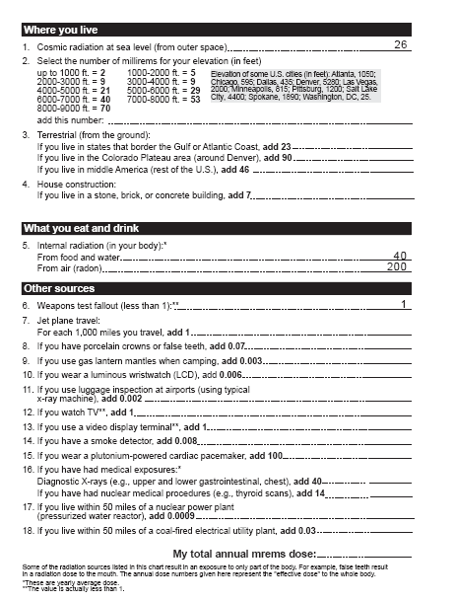
Personal Radiation Worksheet

Cloud Chamber Experiment
Distribute materials and directions for Cloud Chamber experiment. (Pre-paint container bottoms to save time.) While radiation cannot be seen, the cloud chamber allows you to see the tracks it leaves in a dense gas.
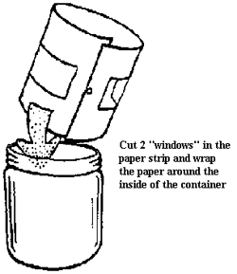
Materials
small transparent container with transparent lid
flat black spray paint
blotter paper
pure ethyl alcohol
radioactive source (cloisonné jewelry, commercially available source from a science supply house, or luminescent clock face)
masking tape
dry ice
Styrofoam square
flashlight
gloves or tongs to handle the dry ice
First, paint the bottom of the container with black paint and let it dry. Then cut the blotter paper into a strip about as wide as the height of the container. Cut two windows in the strip, as shown, and place it against the inside of the container.
Directions: Pour enough ethyl alcohol into the cloud chamber to cover the bottom of the container. The blotter paper will absorb most of it.
Place the radioactive source in the cloud chamber and seal the lid with tape.
Place the cloud chamber on the dry ice to super-chill it. Wait about five minutes.
Darken the room. Shine the flashlight through the windows of the chamber while looking through the lid. You should see "puffs" and "trails" coming from the source.
Have students record their observations. What did they see? How does this work? What conclusions can you draw from this? Do you see radiation in the cloud chamber? How is this possible?
Answer: These are the "footprints" of radiation as it travels through the alcohol vapor. The vapor condenses as the radiation passes through. This is much like the vapor trail left by high flying jets.
Other Ideas To Explore
Try to identify these footprints:
Alpha: sharp tracks about 1 cm long
Beta: thin tracks 3 cm to 10 cm long
Gamma: faint, twisting and spiraling tracks
Caution: Dry ice should be handled very carefully! It can burn unprotected skin.

